**GIT HUB**

sudo apt-get update

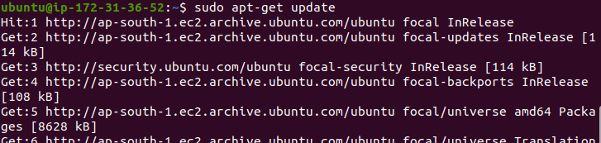

sudo apt install git

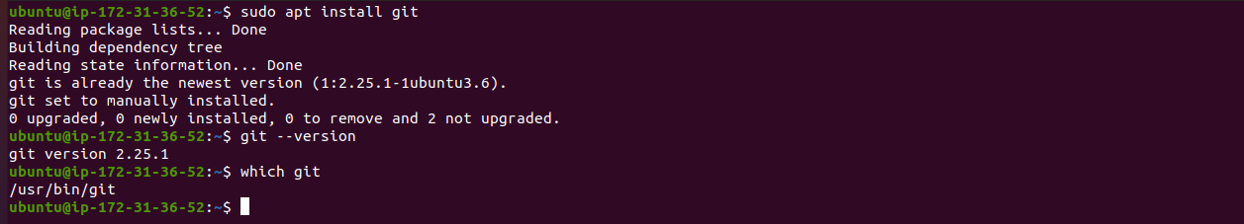

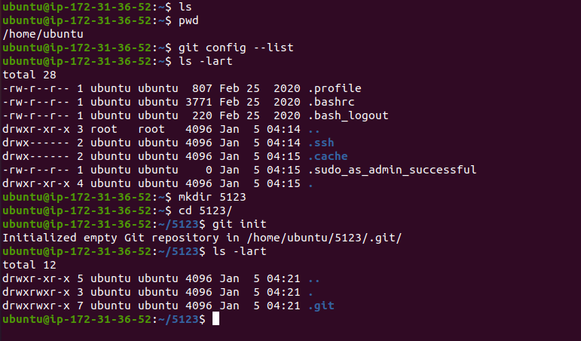

ls

pwd

mkdir $directoryname

cd $directoryname

git init

ls -lart

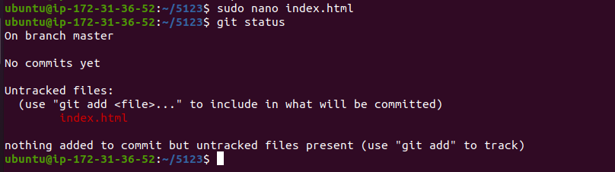 sudo nano index.html

git status

git add .

git status

git commit -m “add html file”

git push origin $branch

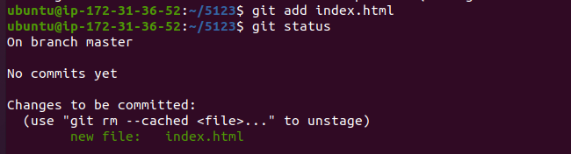

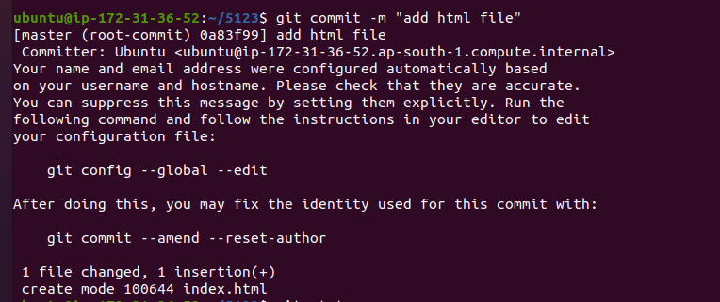



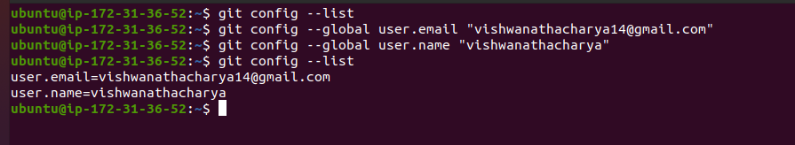

git remote add origin git@github.com:vishwanathacharya/5123.git

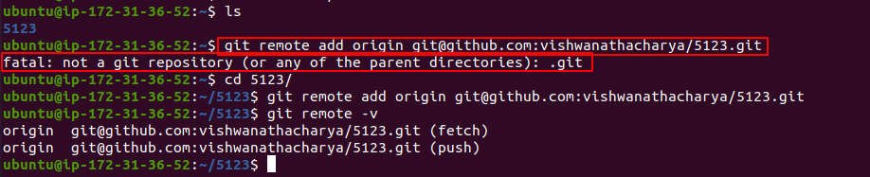

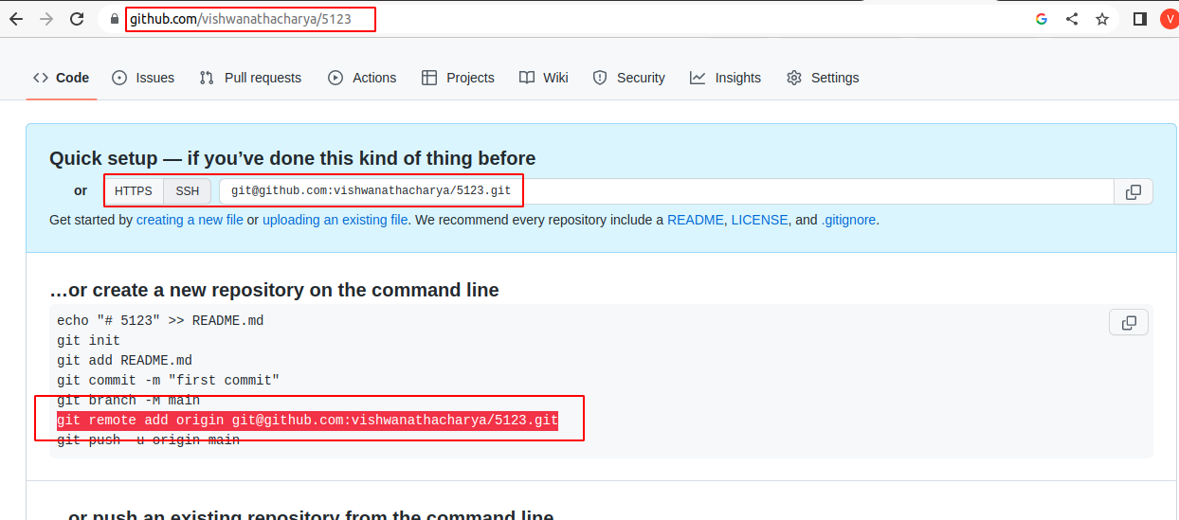

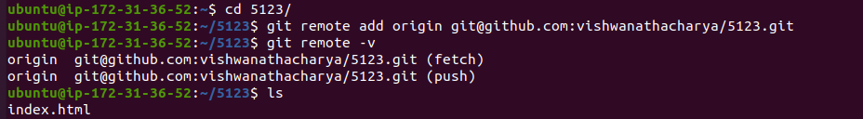

git remote -v

ssh-keygen

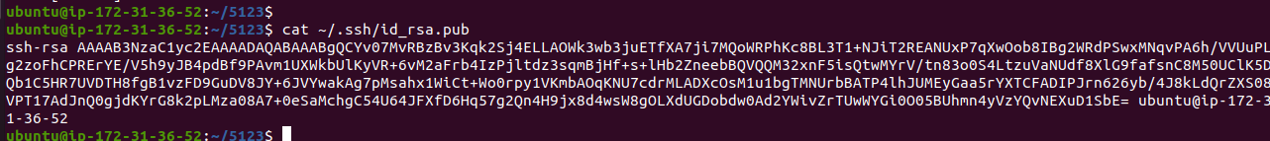

copy id_rsa.pub and add github

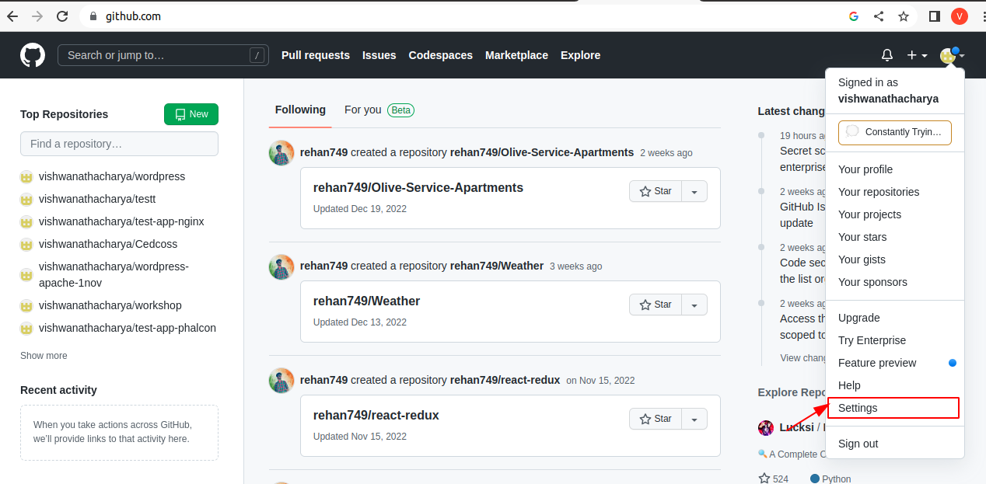

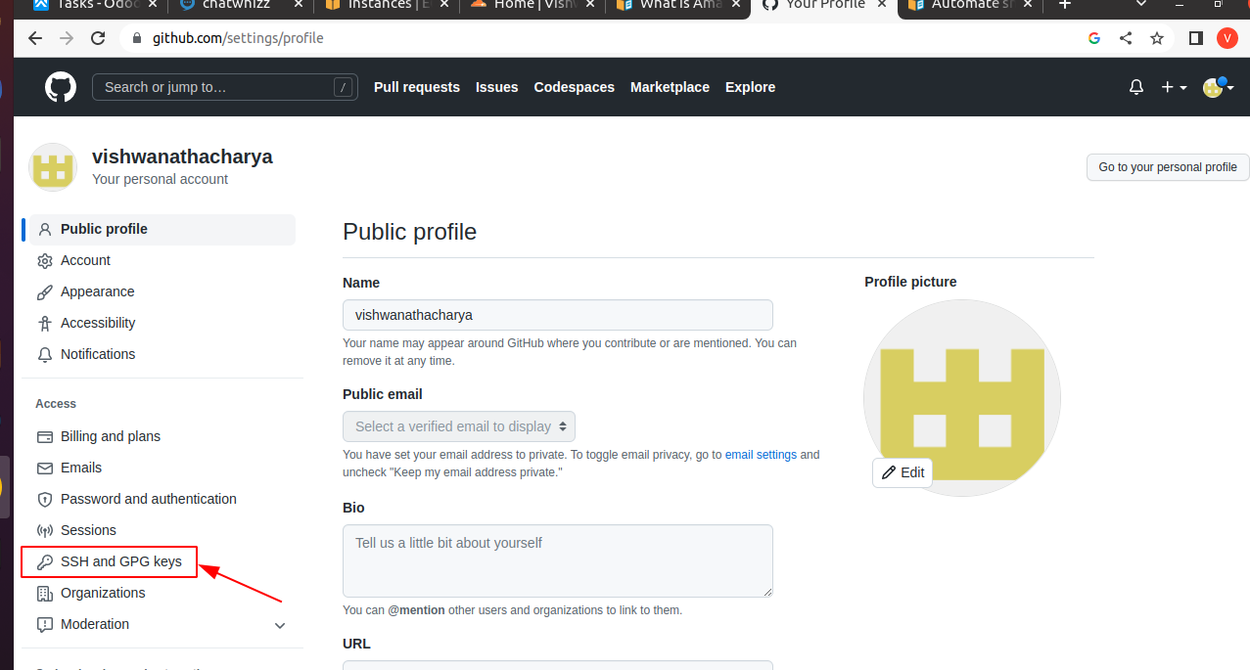

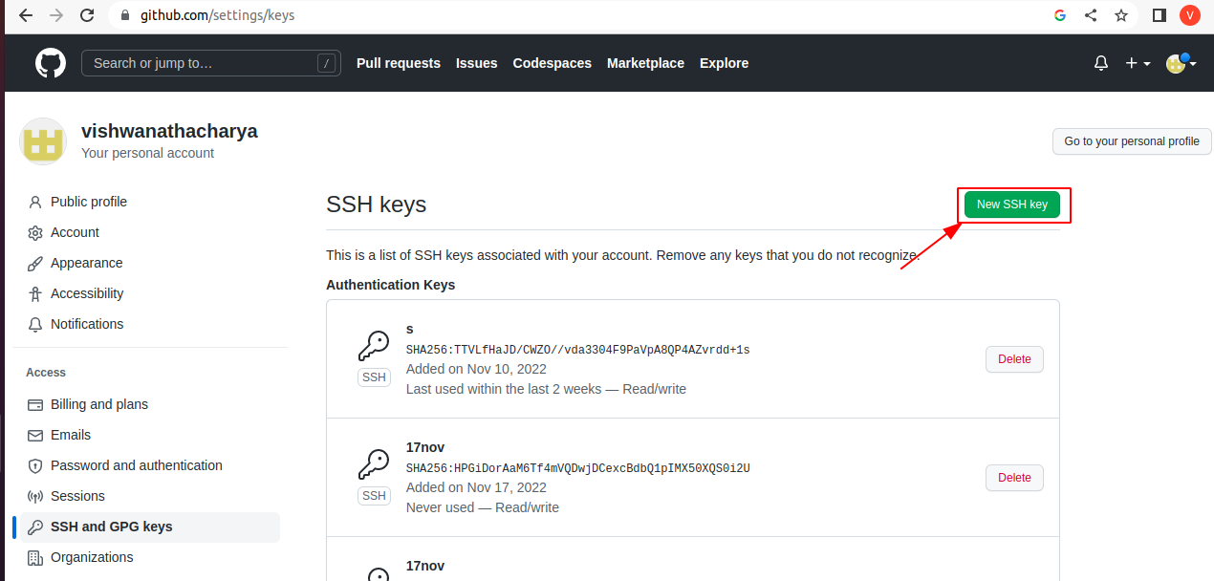

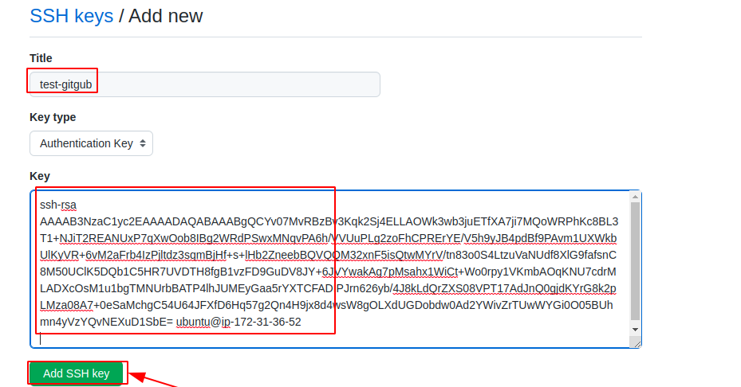

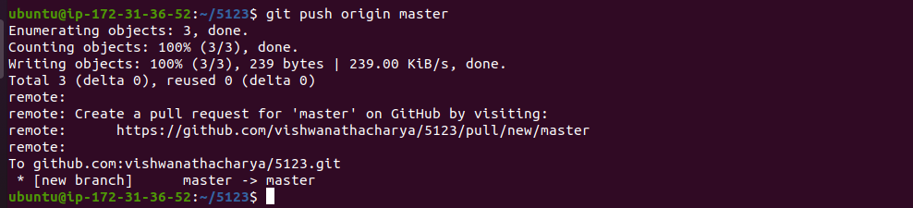

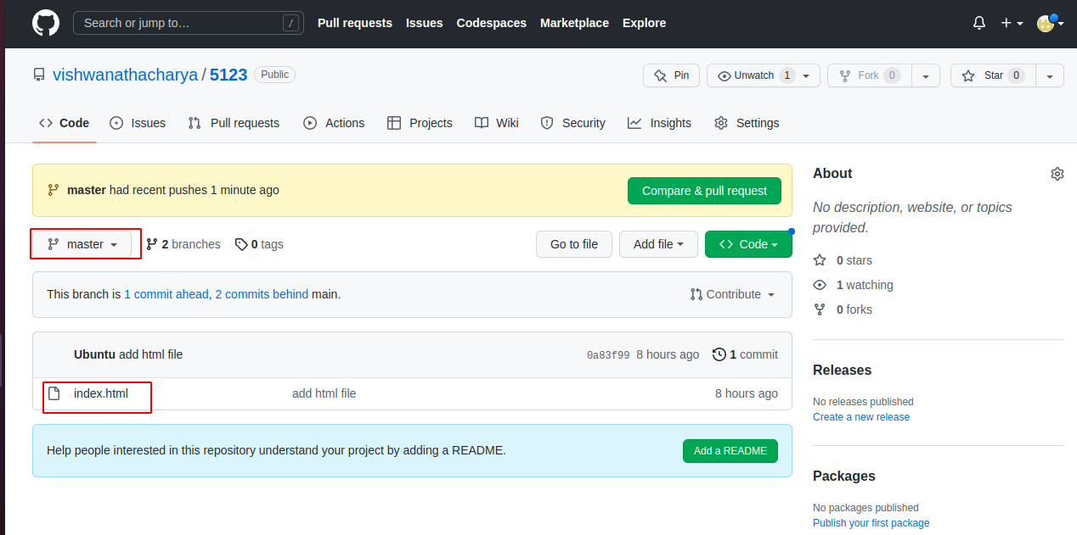

**Git Branch**



git branch

{to check branches & current branch}

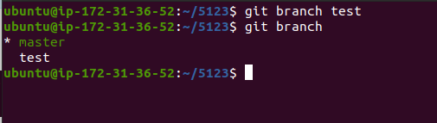

git branch test

{create new branch }

git checkout test{

switch branches

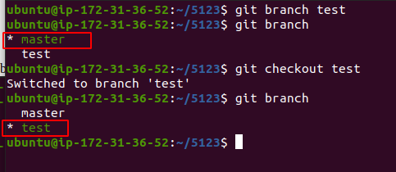

create & switch branch

git checkout -b txt

